Name:Udaya Byreddy

Lab id: 6_2

Student id: 3

Patner name: Madhuri Sarda

Student id: 21

Assignment No: 5 Ionic application using Cordova plugin

Below are the screen shots of code snippets of login, create user and get current location using Cordova plugin.

1. Code snippet for login page

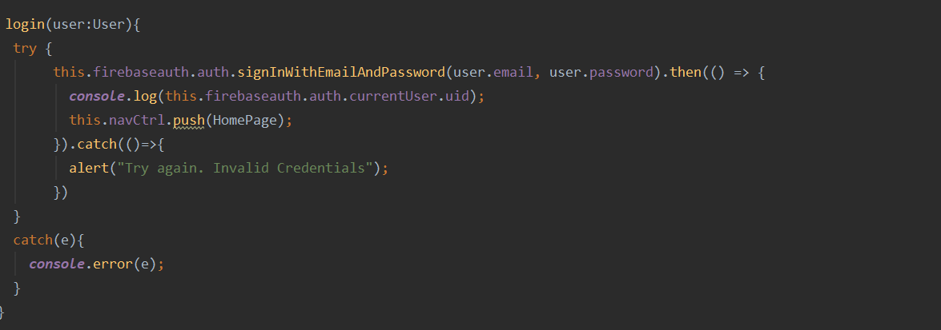

1. Code snippet to create page

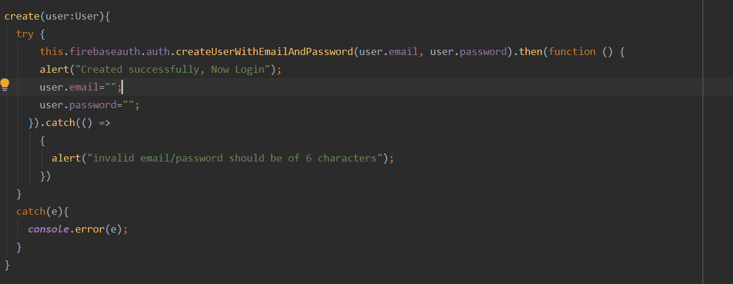

1. Code snippet for getting current location.

